**Type of logo**

1. **Monogram:**

* Also known as Lettermark
* A Monogram or Lettermark is another typography based logo, instead of full brand name they are based on the brands initials, often for long brand names. Focuses on letters rather than symbols.

*“Monograms are a strategic tool that enhances brand identity, recall, and versatility.”*

**Use:**

* If you have a long or multi-word brand name and want to shorten it.
* If you want a logo that’s simple and versatile.
* If you require a logo that works at any size.
* [Monogram isn’t preferred if your brand isn’t well known].

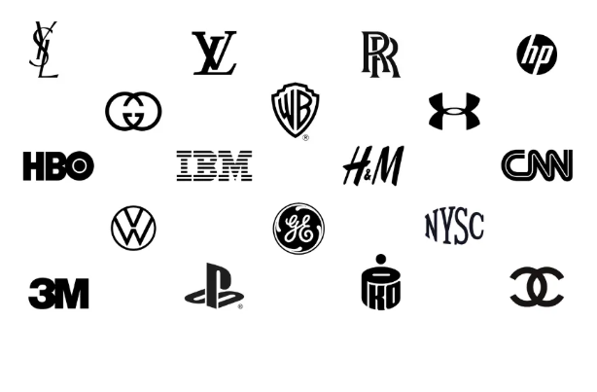

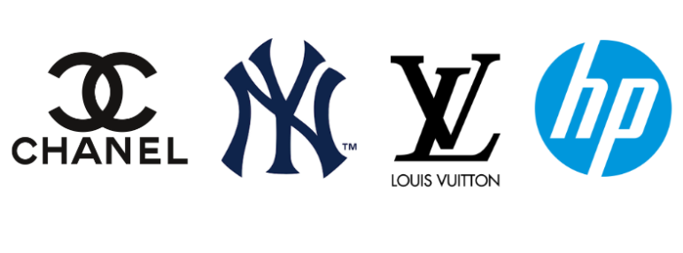

1. **Wordmark:**

Also known as logotypes, Similar to monogram but are just made up of one word (the brand name). In wordmark typography is Front and Centre so one should be familiar with all the element, rules and principles of typography design.

Eg# Google, Visa, Sony, Loreal, eBay.

Use:

* If your brand name is concise enough to be spelled out in full within the scope of a logo.
* If the brand name is both catchy, distinct and memorable combined with a strong typography.
* Ideal for building brand name recognition and ensuring simplicity and clarity.

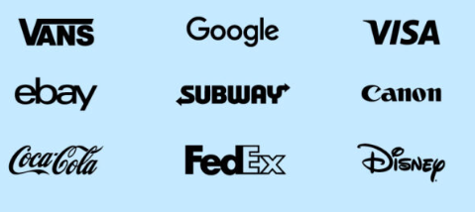

1. **Pictorial Mark:**

* Also known as Brand Mark or Logo symbol.
* It is an icon graphic based logo compromises a single image, icon or graphic. If you can come up with one imagine that conveys your brand without requiring any further explanation.
* Requires strong brand Recognition.

**Emblematic logo:** Serving as a symbol of particular quality or concept.

[Since pictorial mark can be considered an **emblematic logo**, as it is a type of graphic-based logo that uses an icon or image to represent a brand, making it recognizable and potentially iconic over time. While not all pictorial marks become emblems, a successful one distills a brand's identity into a powerful, memorable symbol that stands for the company, much like an emblem represents a group or idea.]

**Use:**

* If you want to design a logo that’s memorable and unique.
* If there’s an obvious symbol or icon that captures your brand and is universally recognizable.
* If you want a logo that’s easily scalable and highly versatile.

[Keep in mind if you are designing a pictorial logo for an unknown brand, you can still create a pictorial mark logo but consider combining it with a typographic logo as a start, and it’s considered a good idea if you have a plan for future changes]

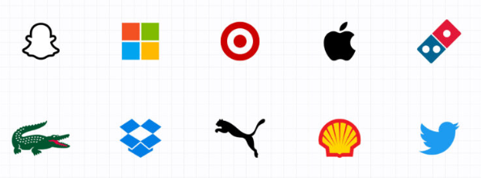

1. **Abstract Logo:**

* Abstract logo is similar to a pictorial logo, in that they use an image, geometrical form or graphic to represent your business.
* Abstract logo design can be extremely powerful and distinctive, but it’s incredibly tricky. You’ll need to create an image that’s entirely unique and unknown to the viewer which itself by no means is an easy task.
* Convey what your company not relying on cultural meaning.
* Using unique color form you can attribute meaning and cultivate emotion around your brand.

**Use:**

* If you want full creative freedom with your logo design, with the goal of creating something highly unique.
* If there isn’t an obvious universal symbol that would represent the brand.

[Bear in mind that abstract logos are open to individual interpretation, which may lead to inaccurate representation of the brand or a failure to connect with the target audience].

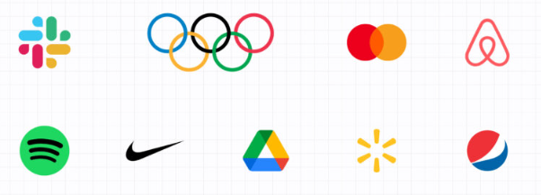

1. **Mascot:**

Mascot logos include a drawing or illustration of a character that represents the brand can be cartoonish. Mascot logos are ideal if you want to evoke a sense of fun and build a friendly, approachable brand, encourage interaction, wholesome vibe.

[Not a good idea to use a mascot logo if you are designing for a more serious, formal, professional brand identity]

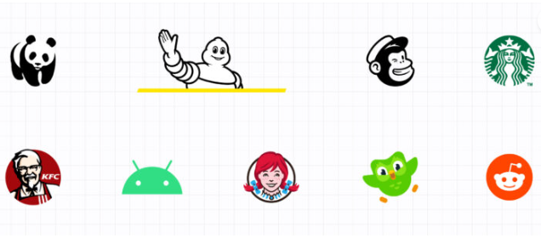

1. **Combination Logo:**

As its name implies its a combination of multiple types of logos. If nothing seems to fit your brand style, just combine different ones. For instance, you can combine an abstract logo with a letter mark. However, such logos are far from simple and may not work well with other themes like minimalist.

**Use:**

* A combination logotype gives you much flexibility and freedom to experiment with different styles until you find the one that works for you.
* It’s a great choice for pretty much any business.

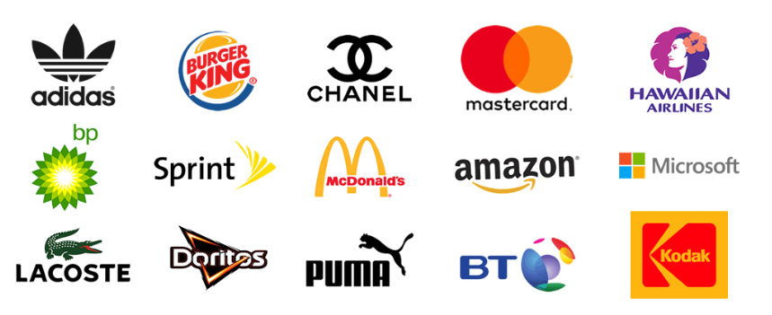

1. **Emblem Logo:**

Emblem logos resemble old-school crests, stamps, or government agency logos. Typically, they include text and symbol that are inside a border or badge. Often look like seals, crests and patches, and give traditional vibes and contain more details. The auto industry is also very fond of emblem logos. While they have a classic style, some companies have effectively modernized the traditional emblem to suit the modern 21st century.

**Use:**

An emblem’s traditional look might be favored by many public agencies and schools, but it can also serve any up-and-coming private business quite well, especially those in the food and beverage industry

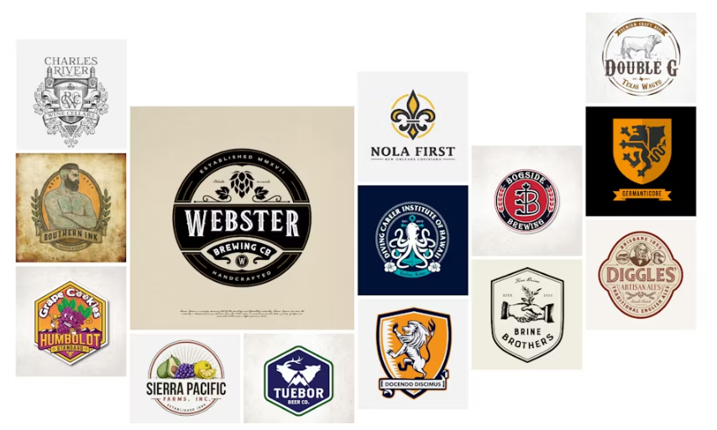

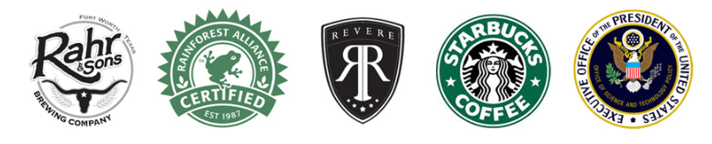

* Variants & Sub-types of Primary Logo Types
* **Dynamic Logo**
* These adapt based on platform, size, or context.
* Example: Google Doodles (changes on homepage), MTV logo (color/pattern often changes).
* Still based on Wordmark or Combination mark, but designed to be flexible.

**Use:**

This type of logo is suitable for brands interacting with customers across several touchpoints such as mobile sites, responsive webpages, digital media, merchandise, traditional media, ads, etc.

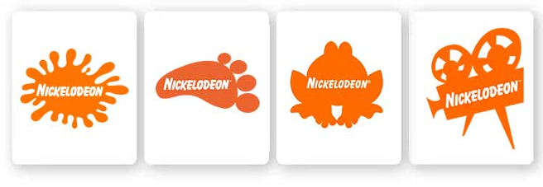

* **Letterform Logos**
* Uses a single letter as the mark.
* Example: McDonald’s “M”, Unilever “U”, Pinterest “P”.
* Sub-type of Lettermark (since it’s just one initial).

**Use:**

[If your brand has high levels of awareness, intorducing a letterform mark may help to increase levels of brand recognition and recall.]

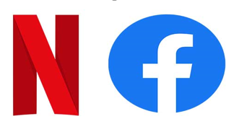

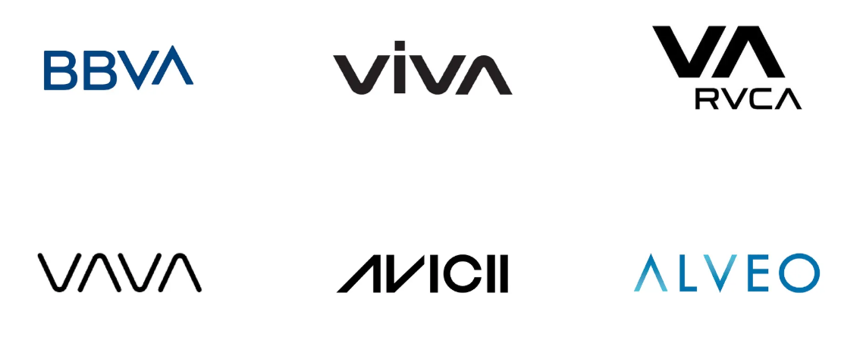

* **Monogram + Symbol Hybrids**
* Mixes an initial with a shape or pictorial element.
* Example: LG (letters + circle shape).
* Falls under Combination marks.

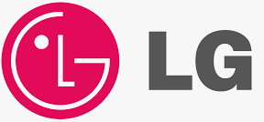

* **Slime / Gradient / Modern Minimal Logos**
* Style trend rather than new category.
* Example: Instagram (abstract pictorial with gradient).
* Just a modern Pictorial/Abstract.

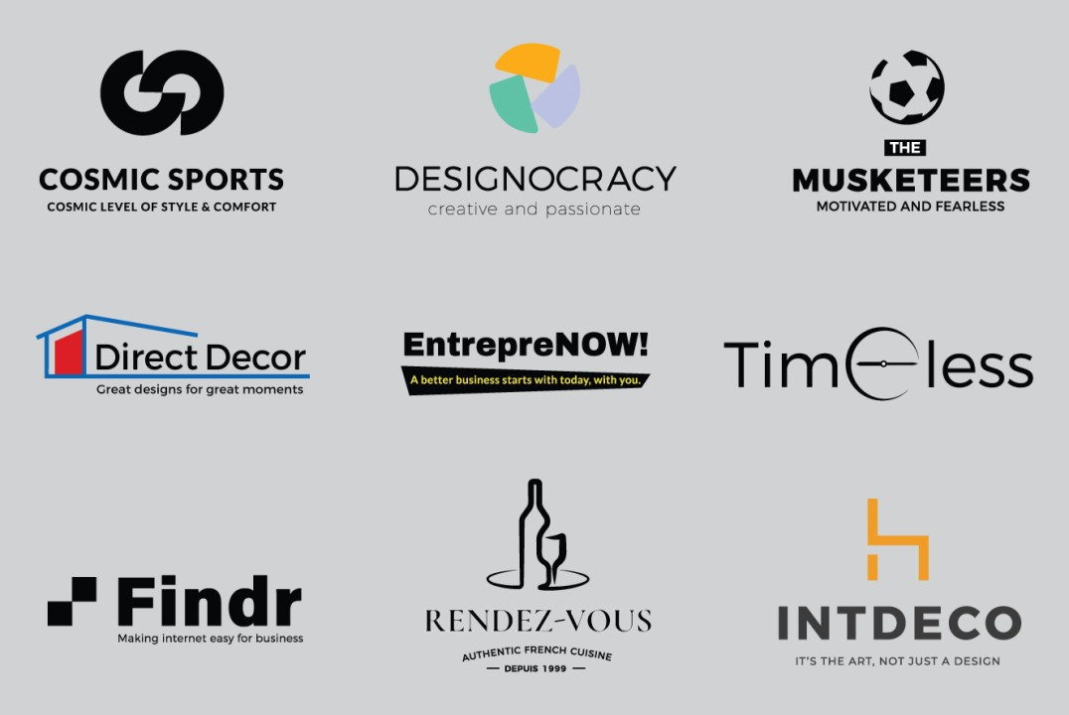

* **Illustrative Logos**
* More detailed, drawing-like, often story-driven.
* Example: Ben & Jerry’s (detailed illustration with text).
* Usually a branch of Mascot or Emblem.

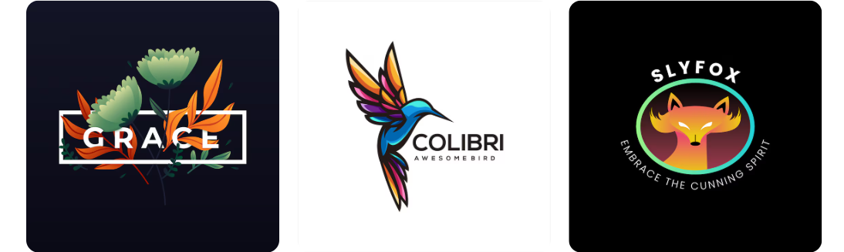

* **Letter-Stacked / Typography Play**
* Brands experiment with arranging text as shapes.
* Example: CNN (connected letters), FedEx (hidden arrow in text).
* Still a Wordmark/Lettermark, but creatively styled.

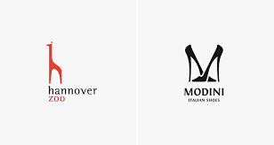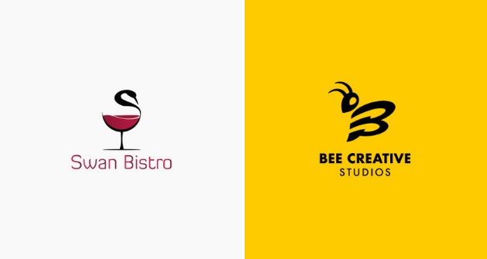

* **Minimalist Line Logos:**
* Ultra-simple, thin line illustrations.
* Example: Airbnb (abstract symbol with wordmark).
* A style trend within Abstract/Pictorial.

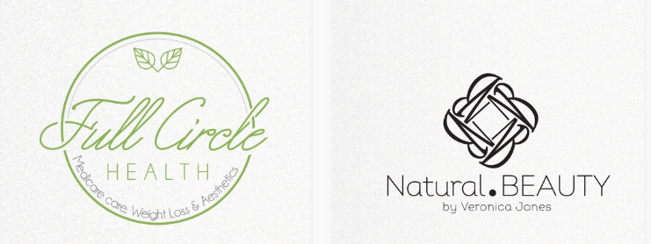

* **Animated Logos**

Animated logos bring a touch of magic to your brand with movement and visual effects. Think Disney's enchanting castle or Google's playful Doodles. To make the most of this type of logo, ensure transitions are smooth and effects are polished to amplify visual impact. Animated logos are fantastic for capturing attention and enriching brand storytelling. For example, Disney’s animated logo adds an extra layer of magic, making each brand interaction a memorable experience.

* **Negative Space Logos**

Negative space or white space refers to the empty areas in your logo that surround your icon, business name and other design elements.

This is typically just empty space that goes unused. But savvy designers like to use negative space to sneak in hidden images or messages.

[FedEx which is a wordmark logo with negative space]

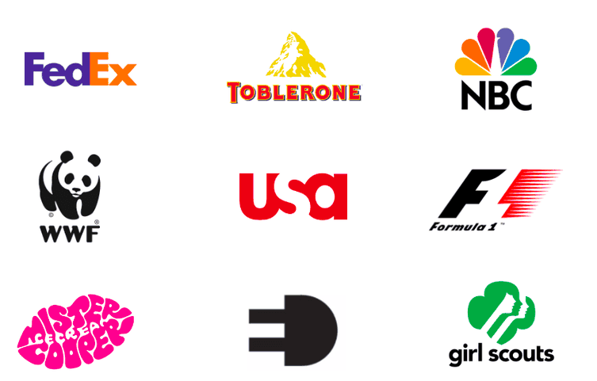

**3D logos**

* 3D logos stand out with their lifelike depth, making your brand instantly memorable, specialized design skills are needed to create a 3D just like emblem logos, 3D designs also need a flat variation for touchpoints where the three-dimensional version won't fit.
* These logos can trick the eye into seeing depth in a flat design, but they truly shine when animated or rendered to look genuinely three-dimensional. If you want to keep up with industry trends, consider simplifying a 3D logo back to a flat design for versatility.
* To make your 3D logo truly stand out, focus on realistic shading and perspective. Versatility is key your logo should look great on everything from business cards to billboards.

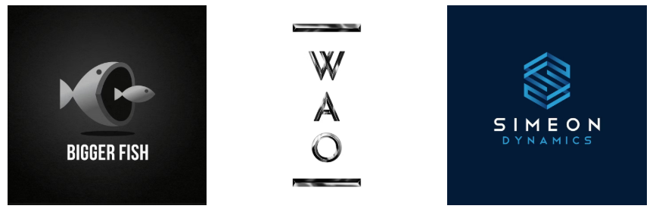

* **Summary:**
* All new/fancy types like gradient, dynamic, flat, minimalist, responsive, illustrative, etc. are branches of the 7 primary categories.
* Designers may market them as “new logo types,” but at their core, they belong to one of the big 7.

**Reference:**

[Monogram Logo](https://www.ebaqdesign.com/blog/monogram-logo-design)

[Wordmark Logo](https://mojomox.com/wordmark-logo)

[Pictorial Logo](https://zoviz.com/blog/pictorial-mark-logo?srsltid=AfmBOopkia0V_Au0u5qVuhLSH8PgcFPZD-tRw-EQJPWjwlL0t45yCwiw)

[Abstract Logo](https://inkbotdesign.com/abstract-logos/)

[Mascot Logo](https://blog.designcrowd.com/article/1915/90-mascot-logos-for-iconic-brands)

[Combination Logo](https://www.logome.ai/blogs/combined-logos)

[Emblem Logo](https://www.logome.ai/blogs/emblem-logos)

**Other References:**

[4 Tips for Creating a Stunning Logo Icon (with Examples) | Narratio](https://narratiopresents.com/article/4-tips-for-creating-a-stunning-logo-icon-with-examples/)

[Types of Logo | BrandMasterAcademy](https://brandmasteracademy.com/types-of-logos/)

<https://www.vistaprint.com/hub/worlds-most-famous-logos?srsltid=AfmBOoo8QApguU00m30eCU6cSRk57DGmEqxBTDa2JxCfMq-4J5NZmniq>

[10+ Best Logo Animation Examples](https://www.ebaqdesign.com/blog/logo-animation-examples)

[Combination Logo - Blog](https://abbydrawdesigns.com/index.php/2024/10/15/combination-mark-logo/)

[Letter Forms](https://nicklevesque.medium.com/7-logo-letterforms-to-let-go-of-f38254273b72)

[Slime / Gradient / Modern Minimal Logos](https://www.linkedin.com/pulse/art-modern-minimalist-logo-design-shuvo-kumer/)

[Types Of Effective Logo Designs | SpellBrand®](https://www.spellbrand.com/types-of-effective-logo-designs#:~:text=Illustrative%20Logos&text=Illustration%20in%20the%20logo%20goes,promotional%20material%20to%20achieve%20branding.)

[4 Different Variation of Logo-Aspen Theory](https://aspentheory.com/4-logo-variations-you-need/#:~:text=A%20stacked%20logo%20is%20a,of%20the%20primary%20logo%20intact.)

[40 Famous Logos and What you can Learn from Them](https://www.vistaprint.com/hub/worlds-most-famous-logos?srsltid=AfmBOoo8QApguU00m30eCU6cSRk57DGmEqxBTDa2JxCfMq-4J5NZmniq)

[3D Logos | 99Design](https://99designs.com/blog/creative-inspiration/3d-logos/)